DR5018S Firmware Upgrade SOP

Step 1: Prepare an Ethernet cable to connect the DR5018S to your computer, and use either a DC power supply or a PoE power source. Set your computer’s IP address to 192.168.1.178.
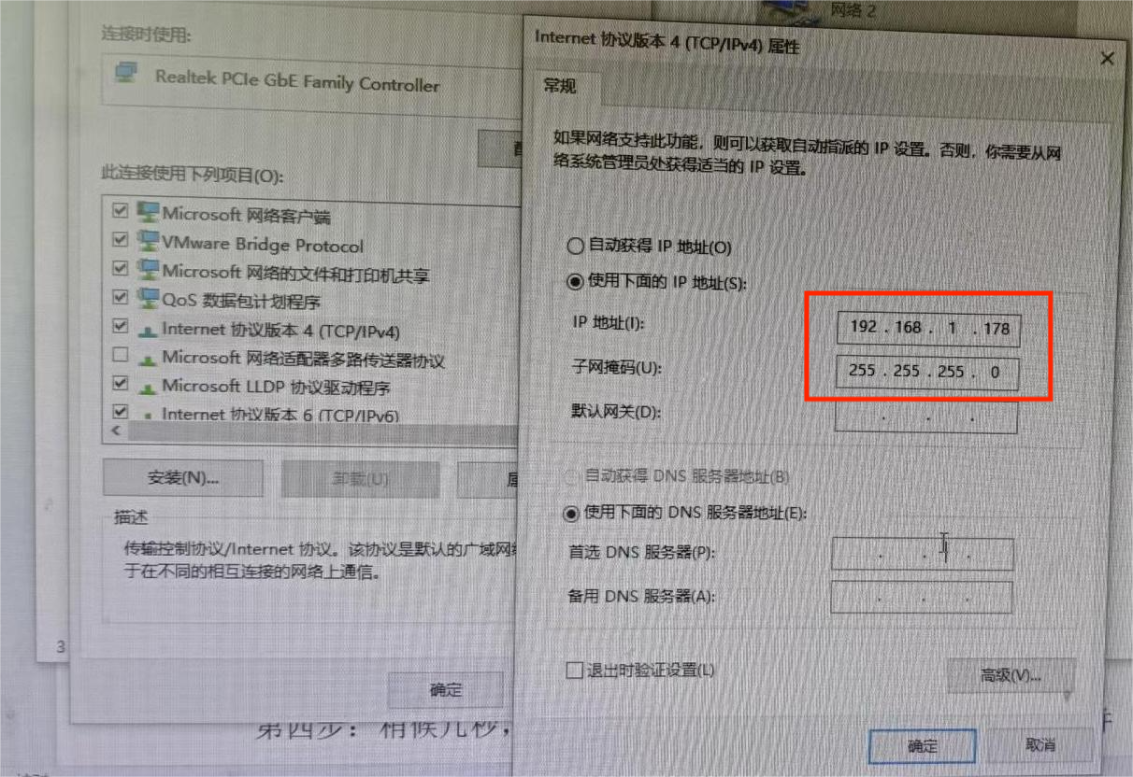
Step 2: Rename the firmware file you want to upgrade to “firmware”, and open the “tftpd32” program located in the same directory.
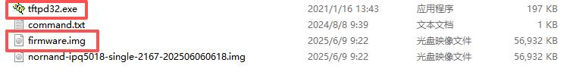
Step 3: Press and hold the Reset button on the DR5018S, then plug in the power supply. As shown in the picture, when the LEDs start flashing continuously, release the Reset button to begin the firmware upgrade.
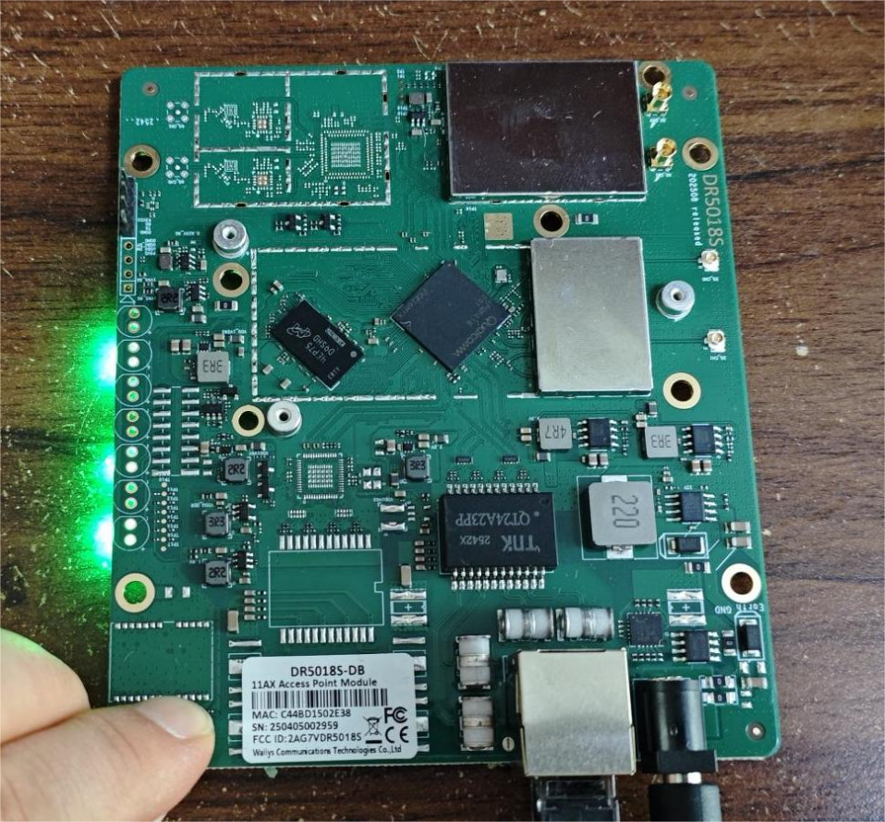
Step 4: After a few seconds, a progress bar will appear on your computer. Wait until it reaches 100% and disappears.
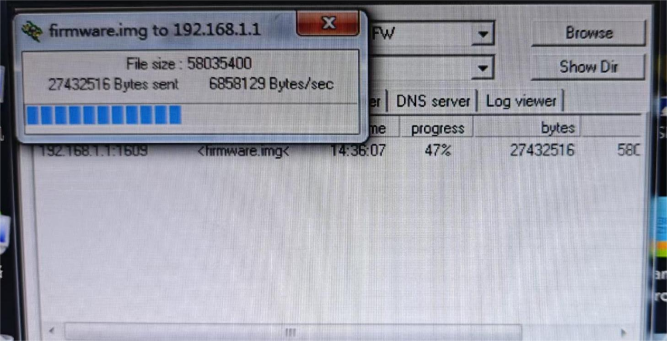
Step 5: Check the LEDs. If all four LEDs flash simultaneously (about once per second), the upgrade is successful, as shown in the picture.
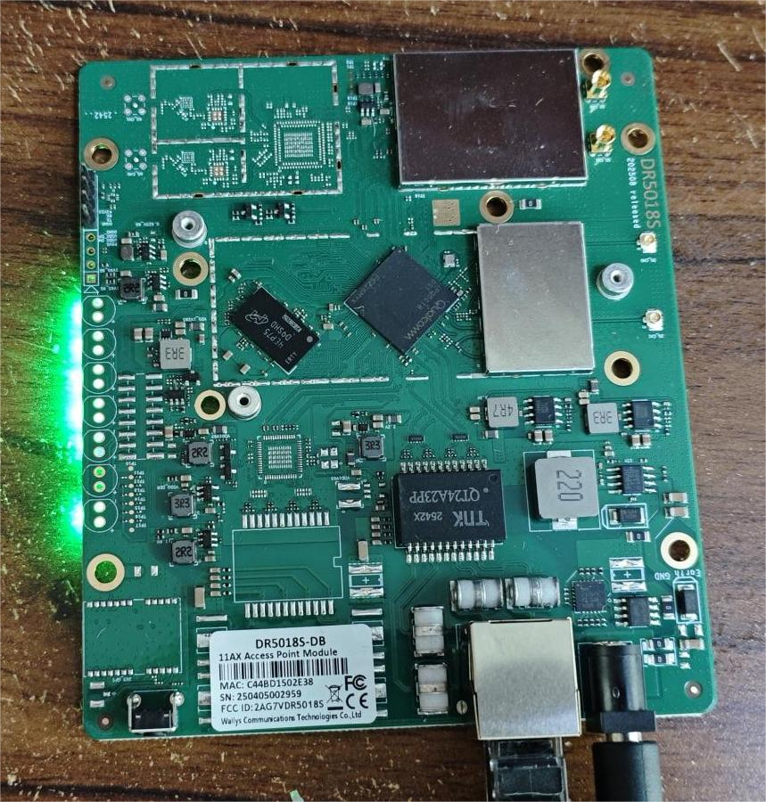
Note: If all four LEDs flash rapidly, the upgrade has failed. You can repeat the upgrade process.

